Chapter 5

# Try It Yourself: Order by a Variable

## Excel Instructions

1. Open Products.csv in Excel.
2. What is the product name with the eighth lowest price?
   1. Verify the first row of Column F is labeled Price.
   2. Select the entire column F.
   3. From the Excel ribbon at the top of the window, go to 'Data'.
   4. Click the button that shows “AZ” with a down arrow beside it. 
   5. Choose “Expand the selection” in the pop-up window.

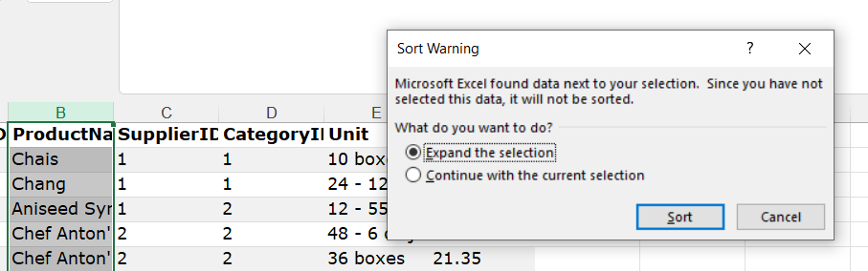

* 1. Click the 'Sort' button.
  2. The list is now sorted from smallest to largest; you may look for the product name of the eighth entry (row 9).

1. What is the name of the product with the eighth highest price?
   1. Verify the first row of Column F is Price.
   2. Click the first cell of Column F to select the entire column.
   3. Go to the 'Data' tab on the Excel ribbon at the top of the window.
   4. Click the button that looks like “ZA” with a down arrow beside it. 
   5. Choose “Expand the selection” in the pop-up window.
   6. Click the ‘Sort’ button.
   7. The list is now sorted from largest to smallest; you may look for the product name of the eighth entry (row 9).